INTRO:
We’ve all seen that online video content is exploding, and more and more organisations are discovering the benefits of having their content subtitled. Not only does it become more accessible to those with hearing impairments, but a lot of people for various reasons don’t have or want their computer speakers on all the time.

In addition, the EU issued a web accessibility directive in 2018, which in Sweden became Tillgänglighetslagen in 2019, and which says that public-sector actors must make their digital information accessible to people with disabilities—including audio description for the visually impaired as well as subtitles.

And of course, with the unexpected challenges of Covid-19 this year, many conferences and other meetings have made the transition into online get-togethers, and that means even more material to be subtitled.

In recent years I’ve had a lot of emails from translator colleagues saying, “I’ve been asked to translate subtitles—what do I need to think about?” Many times, these subtitles we’re given to translate are also automatically generated by voice recognition software, which adds a whole host of additional difficulties. But I’ll get to that shortly.

PART 1:
What do you need to think about when subtitling?

1: First of all, as with all translation (or transcription, because a lot of subtitling is done in the same language as is being spoken in the video), your subtitles have to accurately reflect what’s being said, and the language has to be idiomatic and feel natural. This is especially true of dialogue, but I think we’ve all read instruction manuals that were written in unidiomatic English and the result is always that it’s hard to follow and stay interested in.

2: Second, your correct, idiomatic translation has to be made to fit into segments of no more than two lines, of no more than 37 to 42 keystrokes each. (Keystrokes are what Microsoft Word calls “characters with spaces”.)

3: Third, your two lines of 42 keystrokes need to be on screen long enough for people to be able to read them. Which means that the more words, or keystrokes, your subtitle has, the longer it needs to be on screen.

Basics of subtitling
1. Correct
Accurate content
idiomatic language
2. Subtitle length
2 lines
37–42 keystrokes
= chars with spaces
(fig. 1)
3. Timing
1 short line: 1.5–2 sec
1 full line: 3 sec
2 full lines: 5–6 sec
Automatic subtitling systems
fail at all three of these things.

Correct: Voice recognition is notoriously hit-or-miss. The BBC famously uses automatic captioning for its live broadcasts—which is an admirable attempt at inclusion—and bloopers occur often. A classic one was in the televised funeral the Queen Mother, when viewers were asked—according to the subtitles—to observe a “moment of violence”.

In Swedish, voice recognition systems DO NOT understand skånska. Last year I was asked to translate “existing subtitles” from Swedish into English. It was a workshop for administrators at Lund University and the so-called subtitles were computer-generated. My favorite example from that was when the speaker was talking about how slowly change processes go in large organisations, especially universities. His exact words were: “Lunds universitet är en trög organisation.” Only in skånska. The subtitle said, “Lunds universitet är en terrororganisation.”

Length & timing: Automated subtitling systems may or may not observe the two-line rule, but they do include every word (or sound) the speaker says, and they often result in three or four lines of text, all of which is displayed on screen precisely as long as the person’s voice goes on. Below is an example from a project I worked on this week.

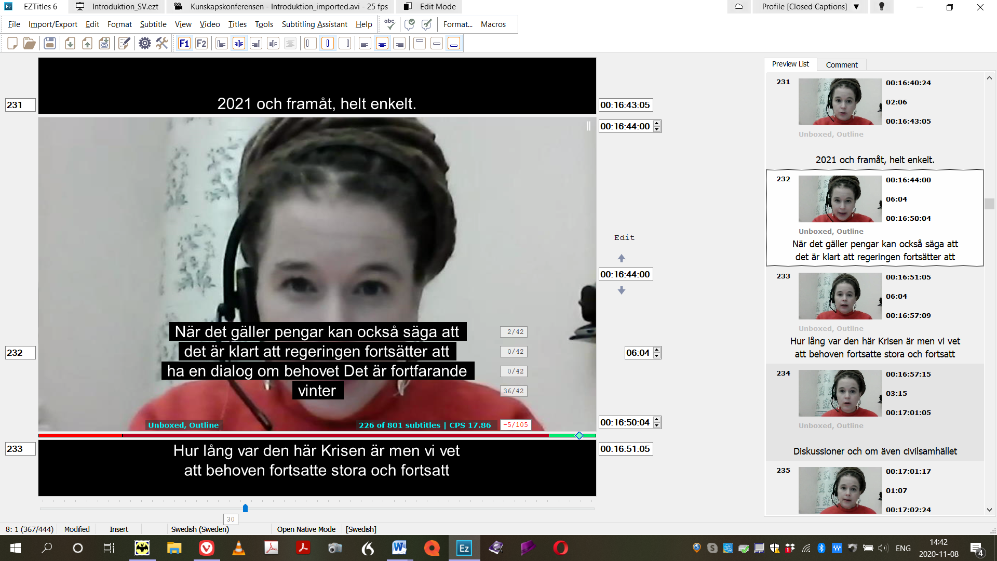

This is our Minister for Culture and Democracy speaking at an online conference. The automatic captions have resulted in four lines of subtitle, covering half her face, and a total of six seconds duration. I split this into two subtitles, two and four seconds long, and the last four words actually belong to a new sentence in a third subtitle.

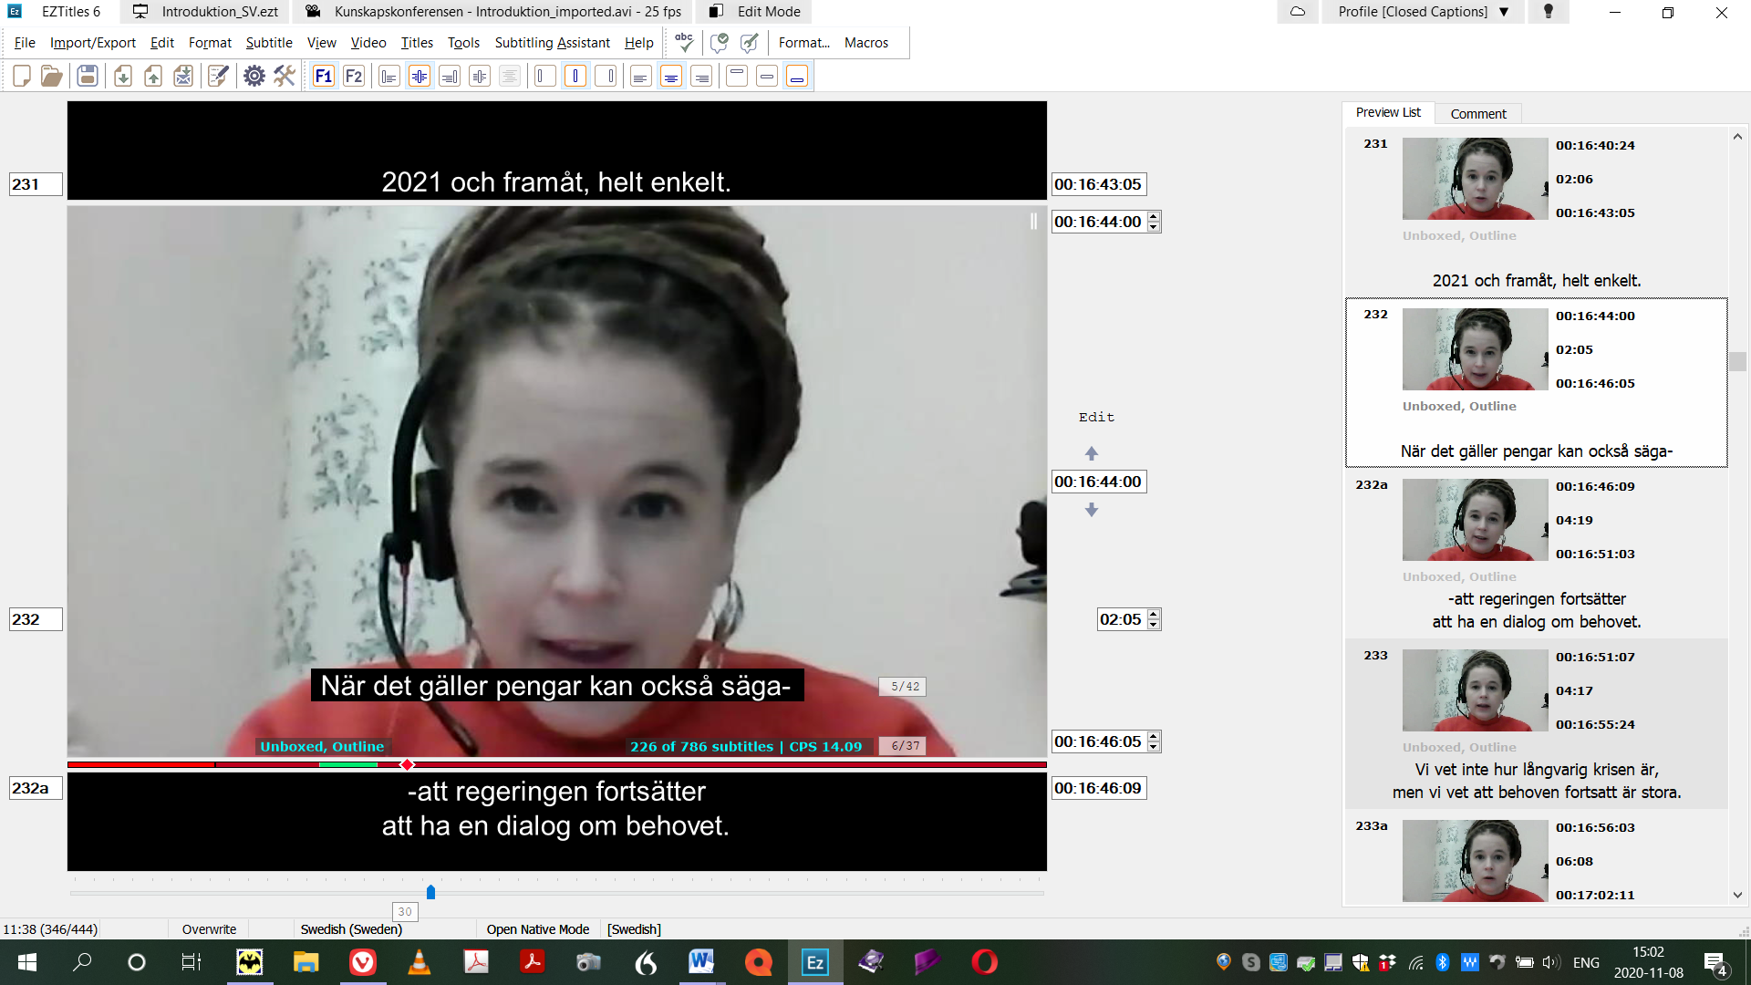

PART 2
So those are the most basic requirements for subtitles. If we go more in-depth, we have these considerations:

Further to correctness: Clarity is extra-important in subtitling. Viewers can’t go back and re-read something they don’t understand. One of the first things you can do for clarity is to eliminate the filler words—the uhhhs and you knows and repetitions, all of which are tricks we use to let people know we’re still talking while our brain is busy figuring out how to say the next thing—and false starts. Because sometimes when people talk—you know when you start a sentence one way, and then change your mind and restart it.

Get rid of all of that and you enhance clarity in your subtitles.

Length: It also has the advantage of automatically condensing your subtitles into shorter lines. Another trick you learn is to use shorter phrases—“to” instead of “in order to”, “several” instead of “a number of”. All of this saves you precious keystrokes.

If your subtitles are translations, you can also sometimes choose a shorter word—“kids” rather than “children”. If you’re doing same-language subtitles, though, viewers can be bothered by hearing one word and seeing another. You might choose to do it anyway, though, for the sake of fitting it all in.

Sometimes, however, you will simply have to choose something to be left out. This is one of the skills of the professional subtitler, being able to choose the least important information in the context to leave out if you need to save space.

Timing: Never let subtitles go across scene changes; when the action has transitioned to a new topic, you don’t want the old topic hanging in the air there. You may think this only applies to movies, but even in an informational video about a business, you don’t want someone talking about the friendly atmosphere of the break room when the scene switches to the manufacturing equipment.

Basics of subtitling | Keys to quality
Correct  Accurate content  idiomatic language | Clarity  Eliminate filler words, flubs, repetitions,  false starts
Subtitle length  2 lines  37–42 keystrokes  = chars with spaces | Condense naturally  Shorter phrases/words  Eliminate nonessentials  (fig. 2)
Timing  1 short line: 1.5–2 sec  1 full line: 3 sec  2 full lines: 5–6 sec | Scene change  Never let subtitles  run across scene changes

PART 3:
Finally, getting into the more advanced nuances of subtitling that really distinguish professional work from amateurs:

An important element of readability is to keep logical units together. A subtitle should preferably consist of a full sentence, or if the sentence is split over several subtitles, then each subtitle should consist of complete phrases.

This is because the brain makes more sense of self-contained units of meaning. Remember in your early years of school when the teacher explained how we often do simple math in our heads by clumping things in groups? You can see a group of three or four things and know how many they are without having to count. And you can see that there’s a group of three and a group of four together, so you instinctively know there are seven, without having to count.

That’s how the brain thinks with phrases and sentences, too. Clumping together the words that form a certain concept makes reading smoother and faster. This is another way of increasing clarity in your subtitles. And something that automatic captioning and most non-professional subtitles ignore.

By the same token, as much as possible, the idea of self-contained units of meaning also applies to line breaks. Even with short phrases—“because of”, “in the long run”, “at a glance”— it’s easier to read them if the words are kept together. Consider these two images:

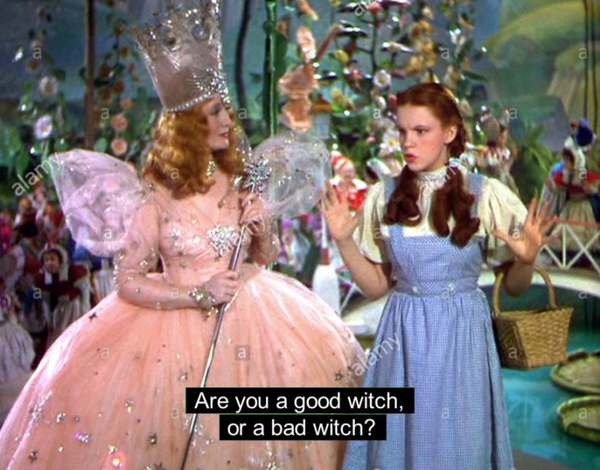
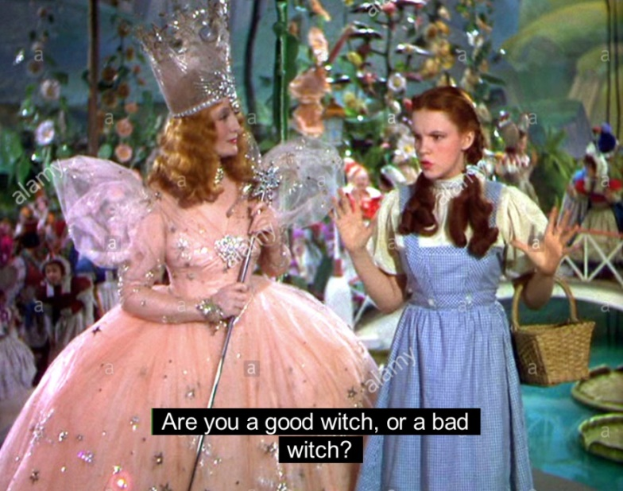

The caveat here is that when you have the limited space we have in subtitles, it’s simply not possible to always do this between lines in the same subtitle. But it’s something to keep in mind. It’s preferable whenever possible for ideal reading smoothness. But between subtitles, it’s a must for reading comprehension.

Timing: Now we’re getting into the real nitty-gritty of technical details in subtitling: timing between subtitles. This is the kind of thing that makes normal people run away in horror, so the best subtitlers are the ones with not only the language skills but also a nerdy techie side. Or if you will, an anal-retentive exactitude.

Studies have shown that the eye needs a fraction of a second between subtitles to perceive that the subtitle has changed. Filmmakers who insert their own subtitles often skip this and it does have a weird effect.

Further, to keep subtitles from looking choppy, the gap between connected subtitles, especially ones that contain parts of the same sentence, shouldn’t be too big. Professional subtitling companies have a set minimum number of frames between subtitles. Depending on the company, that number may may be 2, 3 or 4 frames. You should only leave longer pauses between subtitles if there’s a break of a second or more in the speech.

Professional subtitling programs manage this automatically; you set your minimum number of frames and the program inserts them as you work. This is the main difference between the expensive professional software and the freeware; you can’t control your video down to a frame-by-frame level in freeware subtitling software.

Basics of subtitling | Keys to quality | Advanced
Correct  Accurate content  idiomatic language | Clarity  Eliminate filler words, flubs, repetitions,  false starts | Logical units  Complete sentences, complete phrases.  Wherever possible,  keep full phrases  on the same line*  * (not always possible)
Subtitle length  2 lines  37–42 keystrokes  = chars with spaces | Condense naturally  Shorter phrases/words  Eliminate nonessentials
Timing  1 short line: 1.5–2 sec  1 full line: 3 sec  2 full lines: 5–6 sec | Scene change  Never let subtitles  run across scene changes | Timing between subtitles  2–4 frames between subtitles unless at least 1 sec pause in speech
(fig. 3)

Now, if I haven’t scared you off completely, the subtitlers’ union in Sweden, Medietextarna, a branch of the Swedish Union of Journalists, or Journalistförbundet, published a set of guidelines for Swedish subtitles last year. They have been translated into English, but it appears that the English version is only available on request from Medietextarna.

It contains basically the same information I’ve given here today, but more detail.

https://www.medietextarna.se/wp-content/uploads/2020/03/Riktlinjer-för-undertextning-i-Sverige-1-2020.pdf

